PVZ style game

Introduction

My idea is for a defence style game that involves logic step making while having a fun gameplay loop that involves precise decisions and game progression of more interesting abilities/types . as waves of enemies come towards you and you make fast decisions on your approach on how to prevent the wave reaching the end using different types of defences to survive till the end.

The game will start with a regular menu and UI prompting the user to begging mission will take them into a tutorial where they get shown the basics of the game like what the objective is and to win. Ideally it would be made extra easy to give a incentive that the player is good and wants to keep playing out of pride as the game progressively gets more complex.

The game will have a simple ui where you drag and drop the defence that you want with a displayed amount of cost per unit and also display there special team-up requirements, these team0ups wont necessarily be for all units but among family will have unique powerups when multiple are down in

Later ideas Id like to add

Team-ups between certain classes of defences

New types of levels with a unique twist

Self ideas – enablers in the middle to incentivise team-ups being there with a costly defence to defend it

Project Chicken -eggplant

Project Peanut butter

3 existing products

Inspiration –

Figure 1marvel rivals style team-ups

I will try to incorporate the team up style feature that makes the game so interesting and unique. This will work through specific types of defences that work together to synergise and have new and unique abilities so you think about the team you want to construct because of these team ups to try to maximise potential

|  |  |
| --- | --- |
| Things I like | Things I don’t like |
| Team comp inspired strategy that makes you think about individual picks and how they work together | Shooter style fps focus on aim and raw mechanics rather than preices placement and brain power |
| Special team based powers or teamups that give new powers when special matchups are made | Team co ordination , while fun in this genre of game wont work in a defender style like this as multplayer is unlikely |
| Lots of choice to make unique expericances for every time you play through | Not attacker sided |
| No definite strategy works in every game | Monetisation and skins that make the game feel like it’s a money machine rather than an entertaining game |
|  |  |

Figure 2 ballons tower defence 6 class system and free playability in builds

|  |  |
| --- | --- |
| Things I like |  |
| Class based defences with each type having stronger areas such as military with range or magic with high popping power | Hero system where one type is a lot stronger than the others who passively gets stronger through the game |
| Different pricing on each unit making it a conscious decision to go cheap and a lot or a more pricey option with more risk before that but greater returns | Large roaming area with a single track so all defences are in a specific lane rather than spreading defence to stop multiple and create more risk of investing in to one place |
| Different types of attacks and ranges and unique factors to each type so each unit feels like it has a place and a use in different scenarios such as glue monkey seems usless but can be great at stoping boss style enemies | Power ups that make the game feel easy once played enough as it takes away the strategy and makes it easier to autopilot and make wrong decisions and get away with it |
| A strategy in what is used dependent on map a geographical structures to implement lots of different types depending on each level | A life counter as the game will be in 2 states dead or alive so its binary and doesn’t need a health bar to decline because if you take damage you lose |
| Support style troops that enable more than attack to create cool strategies around enabling one troop as that’s always a fun thing to try and do as a challenge to put a fun twist on the game to see who can be strongest individually | Class of enemies that cant be attacked by other types of defences as it feels bad to not build strategy due to inability to attack types as it will make all rounders more viable rather than individual strategy |

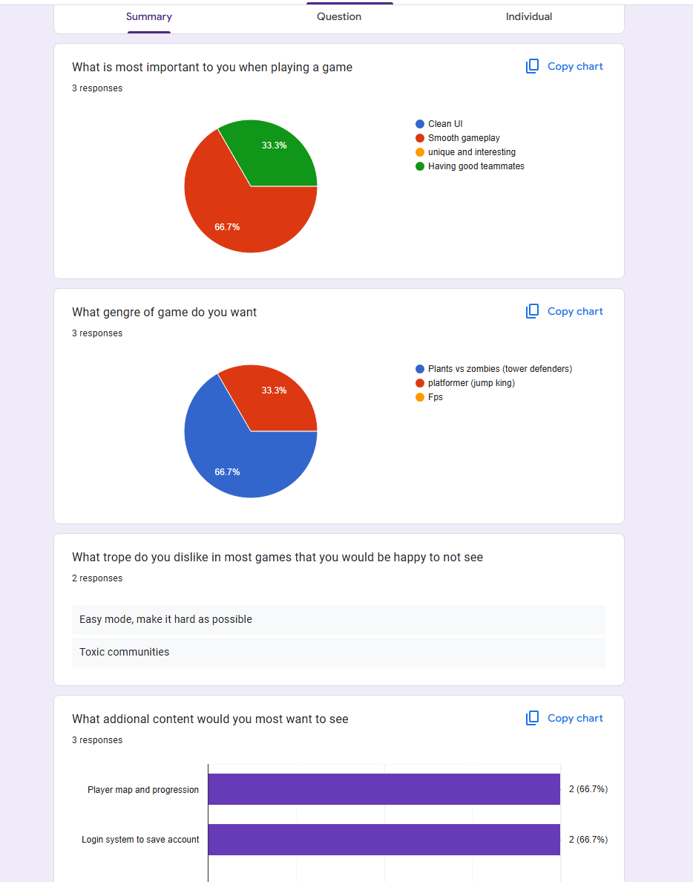

Figure 3 Plants vs zombies style design and gameplay loop of defence style

=

|  |  |
| --- | --- |
| Features I want to keep | Features I want to remove |
| Core gameplay of defend from waves while progressing and developing the lanes as increased hordes approach | Ugly ui that while user friendly feels old and basic and seems unpolished like a last minute add in |
| Pricing strategy to incentivise not spending all in one place and to diversify to reduce risk | Slow moving with no chance to speed up rounds so dependent on speed setting used by user |
| Have investment style troops who generate money high risk high reward to keep placing these as they cant defend but give you more in the long run | I will give an in depth explanation to users that showcases what they do |
| Lawn mower system where you get one reset of the lane before you lose | Types of plants that feel useless or niche and don’t have a widespread use other than a single level |
| Lots of different styles of enemies that have different health move speed and unique factors that make them special | A power up a specific type system where you “grow” plants so they have a single time stronger status that makes the player wait real time to progress |

Stakeholders:

-16-24 nostalgia to original game and its feel and makes players remember there child hood and enjoy the feeling that they used to feel for playing it

For older players who grew up on playing the original pvz games on there mums phone or on their ipad, this game will take that old teen too young adult back to a better time where things were more simple and there biggest worries where if they could afford that chomper or if they had to cut there loses and place a pea shooter. These players are always going to have a game like this in there heart so a game that even touches that feel can make players feel that nostalgia and get involved with my new take on the game. My game will have a cool animated art style where brightly coloured snacks that the players aged 7-9 attached and want to make to there own style of play with kids being involved in the process of making the team and the creativity aspect of the game. These kids will be the future pf the games life so they will be my primary focus with a secondary opinion on original players of the style of game.

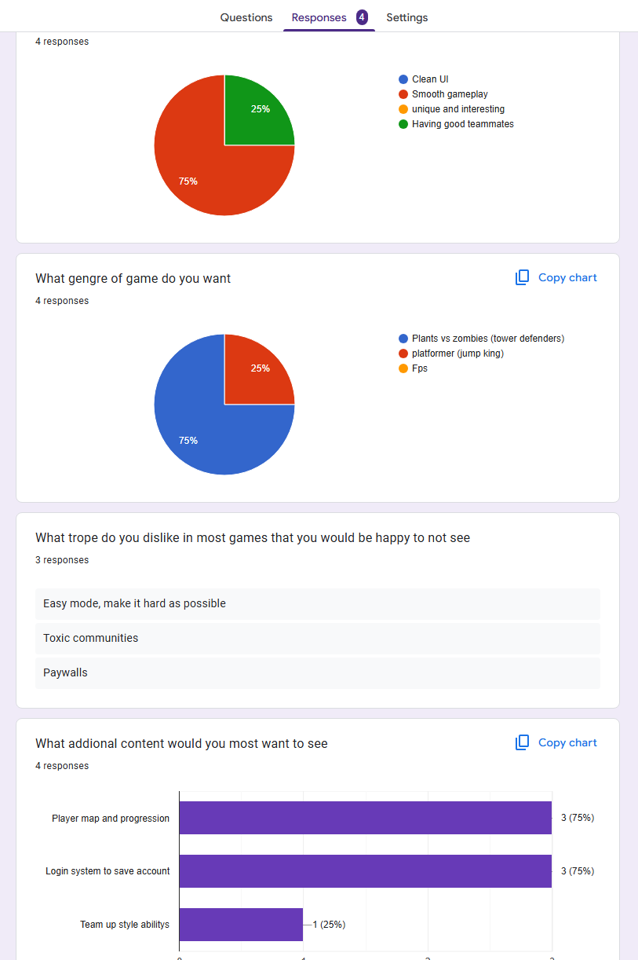

<https://docs.google.com/forms/d/1kP3dtIMNZExSc9rf3_54uduaMGLhsCA7fqNu9ak9my8/edit>

Requirements:

-menu screen to enter game or chose what they want to do

-gameplay screen where game can be played

A victory screen when the level has been completed and the player has survived a set amount of time

A defeat screen when the level has been lost

-basic player agency of placing troops

- a cost for each troops to stop excessive placement

-enemies that can attack troops and activate a loss condition

Features I would like to implement

* A map or progress screen to see how far the player is through the game to give progress as a incentive
* A login system so earned progress isn’t lost
* Team up abilities that make the user have even more options and thought process

If I have time at the end

* An inverse wave function where you are the enemies
* Multiplayer mode
* Allow personalized troops and own specialized units

|  |  |  |  |  |  |  |
| --- | --- | --- | --- | --- | --- | --- |
| 1 | feature |  | Sub features | explanation | justification | importance |
|  | Menu screen | A | Start button | A simple button which hen clicked will take the user to the main game screen | While conducting my research every game I looked at had some begin game feature was always present to not drop the user in right away and give some agency to do different things. This allows the user to get ready especial y for children who have been handed the phone with the app open so they don’t miss out anything | Essential |
|  |  | b | Title | The name of the game displayed on the menu | Its an easy enough feature to add that makes it clear what the user is playing, the title could also tell the user what the game is like. It also is self-promotion should anyone else see the title screen and could intrigue them into playing if they see the gameplay | essential |
|  |  | c | background | A themed background image such as the main colours of the game or a screenshot of gameplay | It shows the user from the start what they are getting in for and makes it less boring to look at keeping the user engaged.id like to make the image a representation of the different game aspects with having progress on there and  What they have unlocked progressing from the start | important |
|  |  | d | HELP button | button which links to instructions on how to play the game | There will be a page with  screenshots and annotations  showing the user how to control the character and complete levels. This is important as when doing my research. As children will be more easily frustrated than myself clear instructions are essential so that they don't get demoralised and give up on the game before they've  even started playing properly | Essential |
|  |  | e | Endless mode option | A endless mode that gets progressively harder and eventually impossible to try and survive as long as possible | This can encourage the user to keep playing and give a break from the core game and try to beat their previous attempts, giving them a sense of progression as they improve off there previous attempts. | wanted |
| 2 | Gameplay | a | Playable levels | A field with different laynes that have individual spots to place units | This is essential to the core gameplay of placing units on different spaces to try and come up with a specific strategy that can be replicated and developed meaning the user can have agency on how the game is played and isn’t stuck in a rigid structure | essential |
|  |  | B | Drag and drop controls | Allows the player to drag and drop on the bored or click where they want to invoke certain responses | This is essential to the player agency of picking what they want to do and where they want to pick it. This will allow precise play in location and allow the user to make the choices on the bored | essential |
|  |  | c | Enemies | Different enemies wit different health and moves peed and damage | This will be used as a progression indicator as they get harder as the level goes on scaling the enemies alongside the defender scaling giving the game a base progression | essential |
|  |  | d | Team ups | When certain groups of defences are down under conditions new they develop stronger | This will give the game a unique twist and make It different from another game in this style as its inspired from the late 2024” marvel rivals” and as a unique game design with a lot of praise I thing it would fit well into this genre of game | wanted |
|  |  | e | Success screen | When the player compleates the game it shows a “victory” screen | This is a important factor in increasing user enjoyment from the dopamine rush of knowing they won from a difficult level making them feel good at the game and a sense of relief. | essential |

There are Some limitations that I would like to implement such as new and varied types of enemies, flipped over sides, multiplayer game modes and more but due to lack of time they are of the lowest priority

Having varied types of enemies beyond the core base few will give the user more interest to adapt and learn from the situation while making the game feel more developed and fluid however this seems like an unreasonable goal at this point in time as the game needs to be fully functional before this could be worked out so its likely not going to happen due to time constraints.

The game will also not be on mobile as it takes even more time to develop and all of the code will need to be redone and has a lot of other factors involved such as apple or android meaning I would need to learn multiple coding languages to recreate the same game.

A online co-op would also be a interesting idea to implement An extension of multiplayer mode, however this would be much harder to implement but would allow me to learn new skills around networks. It would also mean that children could play with their friends even when they can't meet in person, which, considering the several how the world has changed to be more distant and online could be a very useful feature. I would require a code to ensure child safety so there is no interaction with strangers, however this would require a lot of steps to attempt to put it in and has some safety concerns to parents stunting my child section of my players.

Hardware requirements, windows pc, low level CPU and GPU and 4gb of ram should be enough to run the game

Computational methods

Decomposition- I’m breaking down the game into a more basic self not getting involved in powerups of level progression until the underlying base game and only adding basic units until the game is functional and has enemies, defence and a cost system and anything else will come after.

Pattern recognition- there will some repeatable code such as units of enemies and towers with similar base code and just different stats meaning the work can be cut down